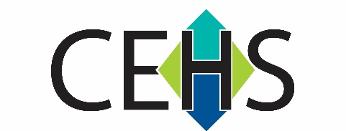
Center for Environmental Health and Susceptibility (CEHS)

Pilot Projects Program 2024-2025
Second Call

APPLICATION COVER PAGE - Applications Due June 7, 2024
Project type (circle one) | Single Investigator or Team Science
Primary Focus Area (circle one) | Cardiopulmonary Disease | Developmental Disease | Environmental Cancer | Other

Project Title

Principal Investigator Name
Title/Academic Rank
Department/School
E-mail address

Co-Investigator’s Name
Title/Academic Rank
Department/School
E-mail address

Are Human Subjects Involved? | Yes or No (circle one)
Are Vertebrate Animals Used? | Yes or No (circle one)

Names and Departments of Co-Investigators - (Last name, First name, Academic Rank, Department)

Please describe interdisciplinary collaborations included in this application

Is PI or other project investigator affiliated with any of the below Centers/Units? Please check all that apply.
- Lineberger Comprehensive Cancer Center -LCCC
- Intellectual and Developmental Disability Research Center- IDDRC
- NC Policy Collaboratory
- UNC TraCS
- Other, specify ___________________________________________________

Please identify three potential reviewers: (Last name, first name, agency, email address, phone number)

