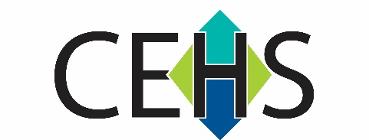
Center for Environmental Health and Susceptibility (CEHS)

Pilot Projects Program 2021-2022

PROPOSAL DEADLINE: February 12, 2021

APPLICATION COVER PAGE

Project type (circle one) | Single Investigator or  Team Science
Primary Focus Area (circle one) | Cardiopulmonary Disease,  Developmental Disease, or  Environmental Cancer

Project Title

Principal Investigator
(Last name, First name)
Title/Academic Rank
Department/School
E-mail address
Telephone number

Co-Investigator
(Last name, First name)
Title/Academic Rank
Department/School
E-mail address

Are Human Subjects Involved? (circle one) | Yes or No
Are Vertebrate Animals Used? (circle one) | Yes or No

Names and Departments of Co-Investigators - (Last name, First name, Department)

Please describe interdisciplinary collaborations included in this application
(required for team science applications)

Please identify three potential application reviewers: (Last name, first name, agency, email address, phone number)

