CENTER FOR ENVIRONMENTAL HEALTH AND SUSCEPTIBILITY (CEHS)

PILOT PROJECTS PROGRAM 2018-2019

GUIDELINES FOR PROPOSALS

NEW EXTENDED DEADLINE!

DEADLINE: MONDAY FEBRUARY 12 JANUARY 29, 2018 (5:00 PM)

The UNC Center on Environmental Health and Susceptibility (CEHS) announces the availability of funding for Standard Pilot Projects based on specifications shown below. The CEHS Pilot Projects Program accepts applications for two types of projects: 1) single investigator, with awards of up to five grants of $30,000 each, and 2) team science, with awards of up to three grants of $50,000 each. The mission of CEHS is to “translate interdisciplinary research on environmental health threats to improve public health in North Carolina”. Environmental health threats are specifically defined as unintentional single or multiple environmental exposures that can influence the prevalence and severity of diseases.
ALL responsive applications will focus on one of the CEHS disease focus areas: cardiopulmonary disease, developmental disease, or environmental cancer. Investigators are encouraged to identify critical windows of susceptibility, study combined exposures, develop new ways to measure personal environmental exposures over time, or focus on engaged scholarship or community outreach and education. Competitive applications will be relevant to the CEHS’ mission, clearly addressing a topic that leads to a better understanding of the interactions between unintentional environmental threat exposure and the pathogenesis of human disease, and will detail specific plans for future application for National Institutes of Environmental Health Sciences funding.
Furthermore, the team science RFA is aimed at supporting exploration of innovative ideas from interdisciplinary research teams interested in the complex interactions between the environment and the pathogenesis of human disease. The main purpose of team science award is to promote collaborations between basic, population and clinical scientists in investigations addressing the CEHS’ mission (noted above).
It is expected that ALL pilot projects will generate preliminary data that will lead to new grant proposals, especially proposals to the National Institute of Environmental Health Sciences. All successful applications will articulate plans for extramural funding applications. Funding for these awards is made possible by support from the National Institute of Environmental Health Sciences (NIEHS): P30ES010126.
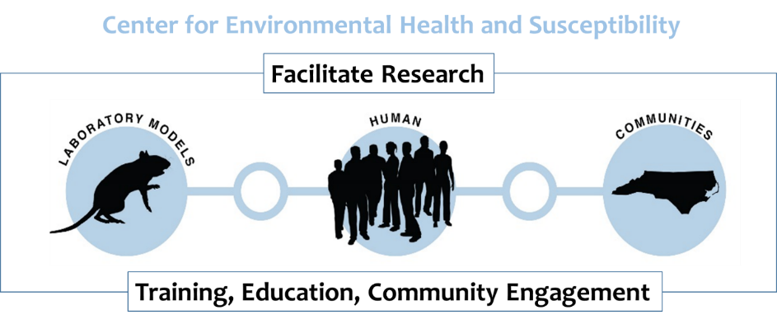
Application format: The PI should submit a five-page application following an abbreviated R01/R21 NIH format: specific aims, significance and impact, approach, human subjects, vertebrate animals, collaborators, and references. The emphasis of the proposal should be on the significance and impact of the proposal, with minimally sufficient detail to support evaluation of the approach. Proposal text is limited to five pages, single spaced, using Arial 11-point font, and half-inch margins. The application cover page, 180-word abstract, budget and budget justification, and references are not included in the five-page limit. Applicants should submit a single file (MS Word, as email attachment) to the CEHS Program Manager, Michael Sanderson, Michael_Sanderson@unc.edu. A complete file should include: cover page, 180-word abstract, five page proposal, references, budget and budget justification (using NIH format pages PHS2590) and letters of support.
Applicants are required to use one or more of the CEHS Cores (information about the CEHS Facility Cores is available on the CEHS Website: http://sph.unc.edu/cehs/facility-cores/), which include:
1. Integrative Health Sciences
2. Biostatistics and Bioinformatics
3. Molecular Analysis
4. Community Outreach and Engagement
The applicant should contact the appropriate Core Director early in the application process and must include in the proposal a letter of support from the corresponding Core Director.

Application Review: A two-tiered review process will include: 1) evaluation by external reviewers (selected by the applicant and CEHS Research Theme Leaders) utilizing standard NIH review sheet and review criteria for unsolicited R21 applications. Briefly, per NIH, “The R21 exploratory/developmental grant supports investigation of novel scientific ideas or new model systems, tools, or technologies that have the potential for significant impact on biomedical or biobehavioral research. An R21 grant application need not have extensive background material or preliminary information. Accordingly, reviewers will focus their evaluation on the conceptual framework, the level of innovation, and the potential to significantly advance our knowledge or understanding. Appropriate justification for the proposed work can be provided through literature citations, data from other sources, or, when available, from investigator-generated data. Preliminary data are not required for R21 applications; however, they may be included if available.” 2) Evaluation by the CEHS Executive Committee for relevance to the Center’s mission and priorities.

Funding, Allowable Items and Budget: The budget and budget justification must be detailed, and should follow the format of the current NIH Budget and Budget Justification pages. Funding will be permitted for personnel, supplies and equipment. For personnel, the appropriate cost for fringe benefits should be included (23.293% for social security and retirement of permanent staff; 7.65% for social security of temporary employees). Health insurance for permanent staff and Graduate Research Assistants (GRA) should also be included (current health insurance rates apply; please check with the business office of the corresponding department to confirm the appropriate rates in effect at the time of this submission). If a GRA is hired, the PI should decide if the tuition award cost will be included in the budget (and is consistent with the PI’s departmental guidelines). Funds may not be used for faculty salaries, stipends, travel or publication or page charges. The center does not fund clinical trial research, so proposals involving clinical trials should not be submitted. For funded proposals, budget changes must be requested in writing.

The CEHS Internal Advisory Committee will make final decisions and select proposals for funding in March 2018. Selected projects will be funded effective April 1, 2018.

CEHS Contacts:
For more information on budget and allowable funding, please contact Rhonda Turner, CEHS Business Manager at (919) 966-6142 or rhonda_turner@unc.edu.

For more information on programmatic fit and funding priorities for the CEHS, please contact the CEHS Program Manager, Michael Sanderson, Michael_Sanderson@unc.edu.

