Classroom to Community

Fall 2014 UNC Application

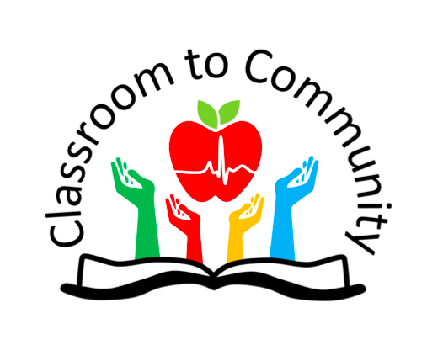

**The Classroom to Community application involves 2 components:**

1. **A completed application form**
2. **A current resume**
3. **Fall class and work schedule (to best of your knowledge)**

**Please email your completed application, resume, and your schedule to Classroom to Community (**[c2c.unc@gmail.com](mailto:c2c.unc@gmail.com))**. Applications will be accepted on a rolling basis, but space is limited.**

**The basics:** Classroom to Community is a semester-long professional development volunteer program under the Student Health Action Coalition (SHAC) at UNC-Chapel Hill that puts you in a new kind of classroom.

You will spend time at UNC learning critical skills in teaching and leadership, then practice teaching in 4th-8th grade classrooms at Maureen Joy Charter School. This is a collaborative, interdisciplinary volunteer experience designed for graduate students from all disciplines in public health, nursing, and medicine. Others may apply as well, but priority will be given to current students in health professions.

Classroom to Community sessions will meet weekly during evenings for an hour and a half, with extra time for work time, at SPH during the fall semester. The weekday will be determined based on group availability. Participants are expected to attend every class session.

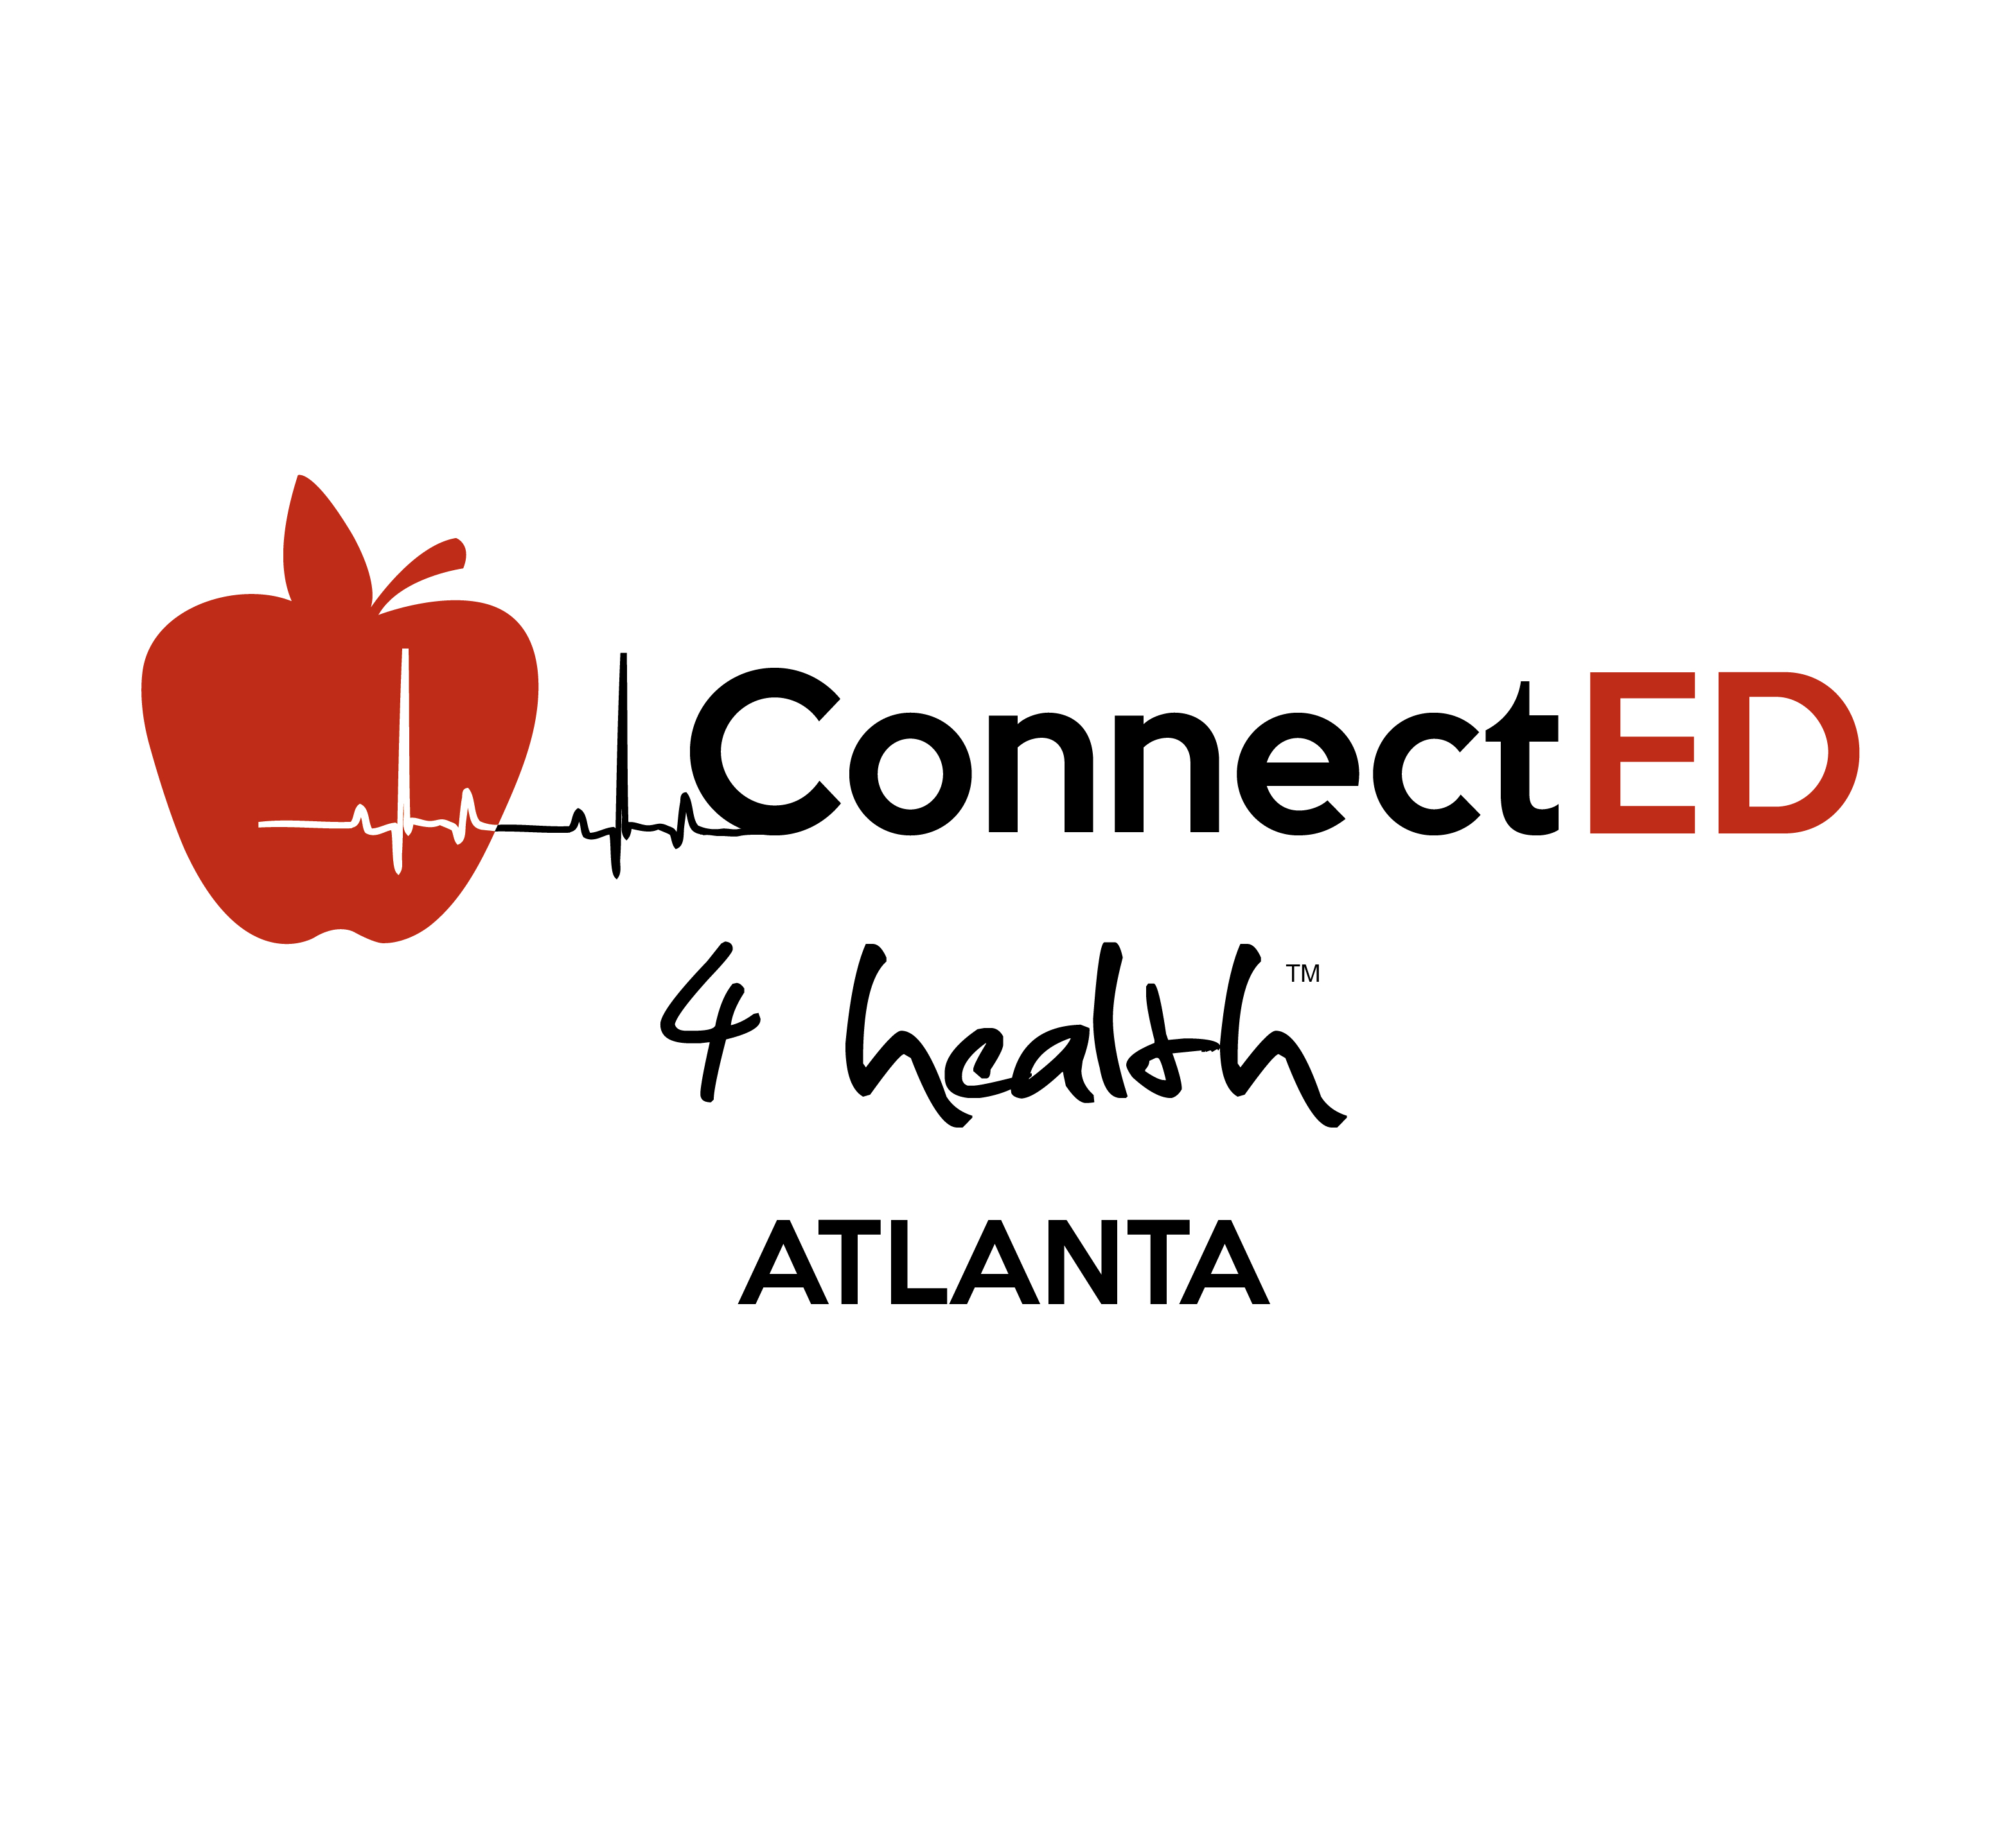

**IMPORTANT INFORMATION ABOUT CLASSROOM TO COMMUNITY**

**(Please read before submitting your application)**

**Q: Do I get course credit for participating in Classroom to Community?**

**A:** While there is not direct credit for acceptance and participation in C2C, you may seek out your own independent study or practicum study credit with a Professor in your department. The course would be 3 credits and we have tools to help you facilitate this agreement, as well as assistance to help you meet goals and deadlines. If you are not seeking credit, this program is situated under SHAC’s Community Outreach division and therefore has similar volunteer training and participation elements. You will gain a critical skill set that will be applicable to future careers in public health.

**Q: How many hours per week should I anticipate for participation?**

**A:** You should expect about 3-4 hours per week in the beginning of the program between meetings and preparation for your lessons. Training sessions are weekly on Monday nights from 6:30-8 pm with optional 30 minutes of additional supported work time until 8:30 pm. During teaching weeks in October and November, you should expect about 6-7 hours per week between meetings, preparation, and travel/teaching, You will need one 3-hour block of time during the school day (8:30 am -2:30 pm) for travel and teaching.

**Q: What are the dates and times of the required training sessions?**

**A:** Sessions will be held weekly 9/1 – 12/1 (excluding holidays and Fall Break), along with one group observation trip to Maureen Joy during the week of 9/8 (two options of times will be available and decided upon as a group to ensure everyone can attend). Timing of classroom teaching will be dependent on your classroom teacher and your schedule but will occur 3-5 times between October 20th and November 17th.

**Q: What costs are associated with participation?**

**A:** C2C and SHAC will pay for most needed materials for lesson plans and teaching (as well as printing if timing deadlines met). Participants are responsible for covering the expense of gas back and forth to the school site, but carpooling is encouraged.

**Q: How do I get to my partner teacher’s school?**

**A:** You will need to provide your own transportation to and from the school—about a 25-minute drive (13 miles).

**Q: Do I need to have prior teaching experience or coursework to participate?**

**A:** No. Overall, we are looking for people who are interested in learning and want to grow as educators, community partners, and leaders.

**Q: What do previous students say about the trainings?**

**A:** C2C existed as a partnership between Teach For America and Emory’s Rollins School of Public Health the past two years. While the model and curriculum are being significantly modified for the UNC partnerships and setting, check out the course blog and read additional Emory stories written about the course here: <http://classroom2community.blogspot.com/> <http://emoryhealthmagazine.emory.edu/issues/2012/summer/briefs/teach_health_for_america/index.html>

<http://news.emory.edu/stories/2012/03/er_rollins_teach_america_classroom_community/campus.html>

**Q: Who teaches Classroom to Community?**

A: Classroom to Community will be led by a dynamic group of current students who are passionate about the intersection of health and education. Several sessions and work times will be also be facilitated by Teach For America corps members, alumni, and staff.

**PERSONAL INFORMATION**

**1. Name: __________________________ 2. Email address __________________________**

**3. Phone Number: __________________**

**4. School (please check all that apply):**

__ School of Public Health

__ School of Nursing

__ Other (please specify): ______________

__ School of Medicine

__ School of Social Work

**5. Department/area of specialty (if applicable): ________________________**

**6. Graduation year:**

__ 2015

__ 2016

__ 2017

__ 2018

**7. Will you have a 3 hour period of free time in your fall schedule between the hours of 8am and 2pm? ____YES _____NO**

**8. Will you be available for our weekly meeting on Monday nights from 6:30-8 PM at the School of Public Health?**

**____YES _____NO**

**if not, what other days of the week are you available from 6-9 pm:**

**___ Tuesday ___ Wednesday ___ Thursday ___ Friday**

**SHORT ANSWER**

***Please answer the following questions. Each response should be no more than 150 words.***

**9. Describe your career aspirations for the next 5-10 year after completing your degree program.**

**10. Why do you want to participate in Classroom to Community?**

**11. What assets would you bring to the C2C program that make you a unique candidate?**

**12. *Optional*: Explain any previous experience working with children or teaching.**

**Please email your completed application, resume, and a your fall schedule to Classroom to Community (**[c2c.unc@gmail.com](mailto:c2c.unc@gmail.com)) **as soon as possible. Applications are rolling but space is limited.**